**Background**   
The competing needs of ride comfort and vehicle handling are met by passive suspensions. In order to deliver the optimal performance for vehicle control, an active suspension system makes an effort to overcome these constraints. The quarter vehicle model is used to study how a suspension system behaves. Before designing the controller, the current work presents the equations to help comprehend the system. Additionally studied is the vehicle suspension system's open-loop response to various road excitations. For the active suspension system, a simple proportional integral derivative (PID) controller design is implemented.  
  
**Introduction**

Almost all vehicles have a suspension system. The purpose of a suspension is to protect the car's body from road shocks for a smooth ride and better handling. The spring and damper make up the passive suspension system. When subjected to various road profiles, a passive suspension system is unable to meet the comfort standards, while semi-active and active suspension systems do so to the best of its ability.

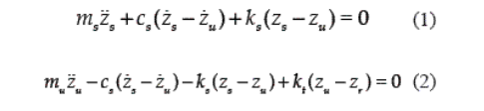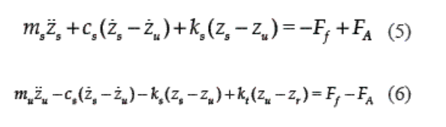**Mathematical Modelling**

Figure 2: Active Suspension

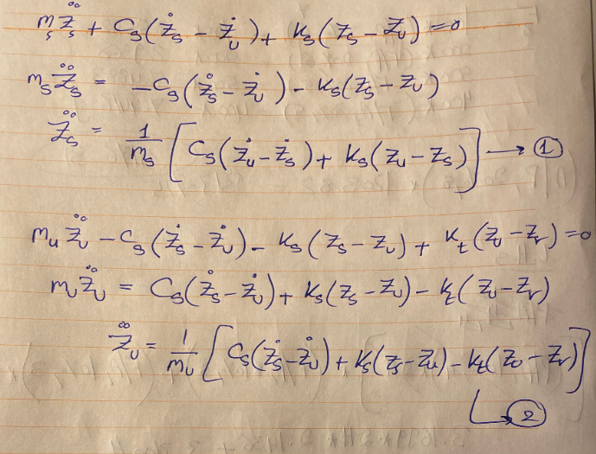

Figure 1: Passive Suspension

Steps

**Screenshots**

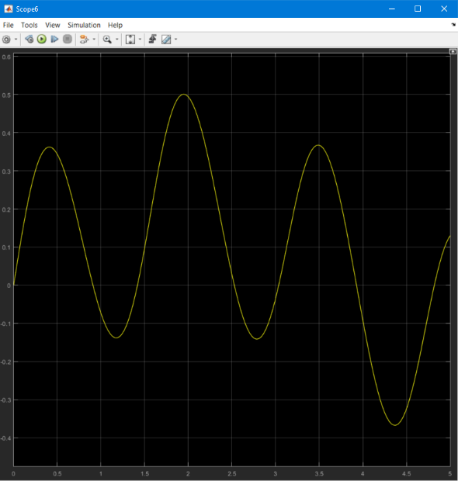

Road Profile

Sprung mass displacement of passive and active suspension

**Conclusion**

We conclude that using active suspension instead of passive suspension allows us to have smaller sprung mass displacement which eventually leads to more passenger comfort. This is also shown using the graphs above and it was only possible due to the force implemented by the active actuators instead of relying only on springs and dampers as in the passive system.

**Done by:**

Adham Ashraf Mohamed 19103316